ESSER Additional Allocation Fund Distribution
ESSER Including HB630, HB632, Learning Loss, Lost Instructional Time, etc.
Updated 2/3/2023
In this document, you will find explanations and clarification on questions OPI has received about additional ESSER allocations, including the bills HB630 and HB632 (including subgrants for Extended and Expanded learning/Summer and Afterschool) and their effects on the ESSER grants.

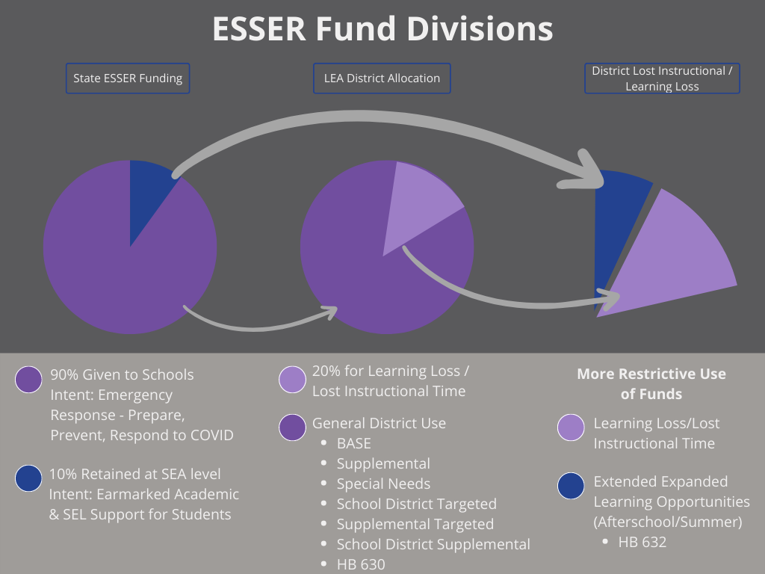
Figure 1: High-level view of how the ESSER funding allocated to the State of Montana is divided into categories, some of which have more restrictive Use of Funds.

Q: How do schools access the additional allocated funds?
A: The funds have already been allocated into the E-Grants applications for ESSER II and ESSER III, in the Budget Pages.
Schools may need to create an E-Grants Amendment in the ESSER II and/or ESSER III Grant(s) in order for the funds to populate within the Grant budget pages. OPI has offered guidance on the E-Grants Amendment process here: E-Grants Amendments OPI Sep22 (pdf) (video)

Note: Learning Loss/Lost Instructional Time, Extended Expanded Learning Opportunities (Afterschool/Summer Enrichment) expenditures are more restrictive than Base, Supplemental etc. This funding makes up 20% of the District’s allocated total. The term “academic impact of lost instructional time” is used in place of “learning loss” experienced by students as a result of the COVID-19 pandemic. Funds in this category must directly impact academic gains (pg14 DOE FAQ).

Q: Do schools need to amend their District budget to access these funds?
A: No, the District budget does not need to be amended.
Note: The E-Grants ESSER II or ESSER III budget may need to be amended if the use of ESSER funds differs from what has previously been budgeted in the Grant(s).

Q: Do schools need to justify/specify their use of the additional funds allocated by HB630 and HB632?
A: Yes. HB630 and HB632 allocated the additional funds under ESSER II and III with the understanding that all ESSER funds must be used to prepare for, prevent, or respond to the effects of COVID-19 on Montana students. Within the E-Grants Budget pages, all budget items must include rationale of how the expenditure(s) prepare/prevent/respond, and how students benefit from the expenditures. This language must be reflected in E-Grants Amendments and E-Grants Cash Requests, to maintain a consistent audit trail. OPI has offered guidance on ESSER Audit Compliance here: Audit Trail Reports & Compliance OPI Oct22 (pdf) (video) (pdf Process After an Audit Finding)

Q: Do schools move the ESSER funds into their General Budget to cover the Increased Enrollment expenses?
A: No, the ESSER funds will be deposited into the Miscellaneous Fund 15 after submitting an E-Grants cash request. The funds cannot be moved out of Fund 15.

Q: How did HB630 and HB632 allocate additional funds to schools?
A: The Montana Legislature appropriated ESSER II funds (through HB630) and ESSER III funds (through HB632) based on the requirements set by DOE. The funds must still be used to prepare/prevent/respond to COVID-19, must meet the same ESSER allowable/reasonable use of funds, and must be used within the same time frames:
- ESSER II - ends September 30, 2023
- ESSER III - ends September 30, 2024

